SYNTHESIS AND CHARACTERIZATION OF SILVER AND ZINC NANOPARTICLES THROUGH GREEN SYNTHESIS USING MANIFERA INDICA LEAF EXTRACTS

¹Nyong Imoh Edem, ²Vincent. C. Nwaokezi ³Ismail .S. Nuhu
1 & 2 Department of Water Resources and Civil Engineering Technology, Federal Polytechnic Ukana, Akwa Ibom State.
3 Department of Civil Engineering Technology, Federal Polythetic Daura, Kastina State.
Correspondent: nyongimoh@gmail.com, 08037100227

ABSTRACT
Nanotechnology has emerged as a promising field with significant applications in medicine, agriculture, environmental remediation, biotechnology, and industrial processes. Among the various methods employed for nanoparticle production, green synthesis has gained considerable attention as an environmentally friendly and sustainable alternative to conventional physical and chemical synthesis methods. This study focuses on the synthesis and characterization of silver nanoparticles (AgNPs) and zinc nanoparticles, commonly reported as zinc oxide nanoparticles (ZnO NPs) when the synthesized product is the oxide, using leaf extract of Mangifera indica (mango). The leaves of Mangifera indica contain several phytochemicals, including flavonoids, tannins, and other bioactive compounds that may facilitate nanoparticle formation by acting as reducing, stabilizing, and capping agents.
In this study, fresh leaves of Mangifera indica will be collected, washed thoroughly with distilled water, air-dried where appropriate, and processed to obtain an aqueous leaf extract. The extract will be used in the preparation of silver and zinc-based nanoparticles by reacting it with suitable metal precursor solutions under controlled experimental conditions. For silver nanoparticle synthesis, silver nitrate will serve as the precursor, while an appropriate zinc precursor, such as zinc acetate or zinc nitrate, will be employed for the synthesis of zinc-based nanoparticles. Changes in colour, where observed, will provide preliminary evidence of nanoparticle formation. The synthesized materials will subsequently be separated, purified, and dried using suitable laboratory procedures. Characterization of the synthesized nanoparticles will be carried out using appropriate analytical techniques to determine their optical properties, functional groups, crystalline structure, morphology. X-ray diffraction (XRD) will be used to determine the crystalline phases and structural properties of the products, while scanning electron microscopy (SEM) or transmission electron microscopy (TEM), where available, will be used to examine particle morphology and dimensions. The study is expected to demonstrate the potential of Mangifera indica leaf extract as a natural source of phytochemicals for the environmentally responsible synthesis of silver and zinc-based nanoparticles.

Keywords: Mangifera indica, green synthesis, silver nanoparticles, zinc oxide nanoparticles, nanoparticle characterization, phytochemicals, UV-Vis spectroscopy.

Introduction

Nanotechnology has been gaining attention recently as a potential platform for future growth in several fields. Nanotechnology has drawn significant attention in the healthcare, engineering and food industries by offering novel prospects in the respective fields. In particular, theragnostic, a cutting-edge combination system of therapeutics and diagnostics, utilize nanotechnology principles for target-specific drug delivery and enhanced bioavailability of active pharmaceutical ingredients (Gome et,.al. 2020, Filippov et,. al. 2020).The field of nanotechnology deals with various synthesis methods, particle size reformations and structural variations of nanoparticles. Nanoparticles are nanosized materials ranging in size <100 nm with high thermal stability, high surface-to-volume ratio, high electrical, mechanical, optical as well as magnetic properties (Chandrakala et,. al .2022).
In the last decade, the use of nanoparticles has been the most significant archetype advancement in engineering, medicine and technology (Naidu et al 2021). Nanoparticles may be classified as organic and inorganic nanoparticles. While metals and metal-derived oxide nanoparticles come under the inorganic nanoparticles classification, organic nanoparticles include solid lipid nanoparticles, polymeric nanoparticles, lipid-based nanocarriers and carbon-based nanomaterials (Dikshit et., al. 2021).However, these methods encounter many downsides, including instrumentations, skilled labour and environmental toxicity. Therefore, the green synthesis method has become an optimal method of choice for nanoparticles, wherein plants and microorganisms are used (Jayachandran et.,al,2021). Furthermore, the green synthesis method of nanoparticle preparation has been considered eco-friendly and safer due to its stabilizing and reducing potentials. Zinc oxide nanoparticles (ZnONPs) possess a wide range of engineering applications, such as catalysis, a piezoelectric device, pigments, chemical sensors, bio-molecular detection, diagnostic, cosmetic material and especially for UV protection (Hasna et.,al 2014). Additionally, ZnO NPs have been demonstrated to possess anticancer, antimicrobial, anti-inflammatory and antidiabetic properties (Sushma et ,al 2016).
Green nanotechnology has originated from green chemistry, which seeks to synthesize Siver and zinc nanoparticles using Mangifera indica extracts. Polyphenols, flavonoids, alkaloids and terpenes which act as potent agents to reduce the metal from ionic state into its respective oxide forms during the process (Vimalraj et, al. 2018). Phytochemicals found in Mangifera indica have replaced the reducing agents’ sodium citrate, ascorbate and sodium borohydride in the chemical manufacturing technique of nanoparticles, AgNPs have been reported to promote electron transfer, also play a crucial role in the catalysis process. Several studies have been carried out to utilize AgNPs as a catalyst in the reduction process of sodium borohydride for the removal of pollutant from water sources. However, methods have been employed for the fabrication of AgNPs which include electrochemical, chemical, co-precipitation and thermal decomposition. Among numerous biomass sources, mangifera indica has been considered one of the most ubiquitous tropical plants, which have been widely investigated in several bio-fabrication process. The extract from Mangifera indica leaves can be applied in the fabrication of silver nanoparticles with uniformly distribution size and good antimicrobial activity against several strains of gram-negative and gram-positives bacteria due to the presence of numerous metabolite such as phenolic acids and flavonoid (Hebeish et., al 2010).

Materials and methods
Silver and zinc nanoparticles were synthesized by a green synthesis technique. Fresh Mangifera indica (Mango leaves) were collected from the mango garden at state college school ikot ekpene, akwa ibom and silver nitrate (AgNO₃) and zinc oxide was purchased from chemical shop, all the chemicals used in the production were of analytical grade and are of above 99% purity.
Table 3.1: List of Reagents and Chemicals

S/N | Chemical/Reagents | Formula | % Purity | Manufacturer
1 | Sodium Hydroxide | NaOH | 97 | Spark Scientific Limited, Northampton, UK
2 | Silver Nitrate | AgNO3 | 99.5 | BDH Chemicals Ltd., Poole,  England
3 | Deionised Distilled Water (DDW) | DDW | 0.5 µS/cm | National Water Quality Reference Laboratory,  FMWR, River Basin, Minna
4 | Zinc Sulphate,  (Heptahydrate), | ZnSO4.7H2O | 99 | LOBA Chemie, Mumbai,  India
5 | Zinc Chloride | ZnCl | 99.5 | J.T Baker Limited,  Philipsburg USA
6 | Ethanol | C2H5OH | 96 | EMD Millipore  Corporation, Germany
7 | Ammonium Hydroxide | NH4OH | 30-32 | Tyuangdang Guanghua  Chemical Factory Company Limited, China
8 | Hydrogen Peroxide  Solution | H2O2 | 30-32 | BDH Chemicals Ltd., Poole,  England

3.01 THE MANIFERA INDICA EXTRACTS
The Mangifera indica leaves were washed severally with deionised water. The leaves were cut with a cutter into small pieces. The beaker was set on a magnetic stirrer with 100 mL of deionised water. Twenty-five grams (25 g) of freshly cut leaves were weighed and put into the 100 mL of deionised water as shown in Plate V. The temperature of the magnetic stirrer was set to 80 °C. After 25 minutes, the solution turned greenish, indicating the formation of leaf extract in water. The extract was filtered and kept for further use. The objective of the screening was to determine the qualitative and

quantitative analysis of the Tannin, Flavonoid and Total Phenols present in the plant part. Tests for the phytochemicals present in the plant materials were conducted.
  - Determination of tannin

Extract sample of 0.2 g was measured into a 50 mL beaker. 20 mL of 50 % methanol was added and covered with parafilm and placed in a water bath at 77 - 80 °C for 1hr. The mixture was shaken thoroughly to ensure uniformity. The extract was filtered using a double-layered Whatman No.41 filter paper into a 100 mL volumetric flask, 20 mL water,
2.5 mL Folin-denis reagent and 10 ml of Na2CO3 were added and the reaction mixture was mixed properly. The mixture was made up to 100 mL mark with distilled water (APHA, 2017). It was mixed well and allowed to stand for 20 minutes for the development of a bluish-green colour. The absorbance of the tannic acid standard solutions as well as samples was read after colour development on the UV-Spectrophotometer at a wavelength of 760 n

3.03 Determination of total flavonoid

The total flavonoid was determined by colorimetric method. Quercetin was used to establish the calibration curve. 0.5 mL of the diluted sample was added into a test tube containing 1.5 mL of methanol. 0.1 mL of 10 % aluminium chloride solution and 0.1 mL sodium acetate were added, followed by 2.8 mL of distilled water. The reaction mixture was incubated at room temperature for 30 minutes. The absorbance of the reaction mixture was measured on the UV Spectrometer at 415 nm. Distilled water was used as blank (APHA, 2017).
  - Determination of total phenol

Two grams (2 g) of the sample were defatted with 100 ml of diethyl ether using a Soxhlet apparatus for 2 hrs. The fat-free sample was boiled with 50 ml of petroleum ether for the extraction of the phenolic component for 15 minutes. Five millilitres (5 mL) of the extract were thereafter pipetted into a 50 ml flask after which 10 mL of distilled water was added. Ammonium hydroxide solution of 2 mL and 5mL of concentrated amyl alcohol were also added. The samples were made up to the 50 mL mark and left to react for 30 minutes for colour development. This was measured at 505 nm. Tannic acid was used to establish the calibration curve (APHA, 2017).
  - Green Syntheses of Zinc Oxide and Silver Oxide Nanoparticles
    - Green synthesis of ZnO nanoparticles

Ten grams (10 g) of zinc sulphate heptahydrate powder was measured into a 250 mL beaker and 100 mL of DDW was added. The solution was stirred using a magnetic stirrer for 30 mins at 150 rpm. Prepared concentration of 50 mL was put in a 100 mL conical flask. The conical flask was put on the hot plate and the temperature was set to 80 °C. Mangifera indica leaf extract was put in a burette, ready for titration. The solution was titrated, while continuously stirred at 80 °C through the use of a magnetic stirrer with the Mangifera indica leave extract, drop by drop and very slowly until a light-yellow colour was formed. The titration was stopped immediately after the solution had changed to yellow, but the stirring was continued for 10 minutes until a colloid of the solution was obtained. The solution consumed 4.9 mL of the Mangifera indica leave extract. The precipitate obtained was filtered with Whatman No. 1 filter paper and washed with DDW until a pH of 7 was obtained. The precipitate was oven-dried at 105 °C for 6 hours and calcined in the furnace at 450 °C for 3 hours to obtain ZnO Nanoparticles (ZnO-NPs). The ZnO-NPs obtained were kept in a glass bottle for further characterisation and use (Sierra et al., 2018).
    - Green synthesis of Ag nanoparticles

Five grams (5 g) of silver nitrate powder was measured into a 250 mL beaker and 100 mL of DDW was added. The solution was stirred using a magnetic stirrer for 30 minutes at 100 rpm. Prepared concentration of 50 mL was put in a 100 mL conical flask. The conical flask was covered with aluminium foil to avoid the photodegradation of silver. The conical flask was put on the hot plate and the temperature was set to 70 °C. The leaf extract was put in a burette, ready for titration. The solution was titrated with the leaf extract drop by drop and very slowly until a light-yellow colour formed. The titration was stopped immediately after the solution had changed to yellow. The solution consumed

2.8 mL of the Mangifera indica leave extract. The precipitate obtained was filtered with Whatman No. 1 filter paper and washed with DDW until a pH of 7 was obtained. The precipitate was oven-dried at 105 °C for 6 hours and calcined in the furnace at 450 °C for 3 hours to obtain Ag Nanoparticles (Ag-NPs). The dried Ag-NPs obtained were kept in a glass bottle for further characterisation and use (Njagi et al., 2010).
  - Characterization of ZnO and Ag Nanoparticles
    - UV – visible spectrometer analysis
The formation of Ag and ZnO nanoparticles was confirmed by the UV-visible spectrometer analysis. 5ml samples were taken during the production of Ag and ZnO nanoparticles. for UV-visible spectrum analysis. Spectral analysis was performed with a UV – 1800 series single-beam diode array spectrometer. The machine collects spectra from 200–800 nm using a slit width of 1 nm. Deuterium and tungsten lamps were used to provide illumination across the ultraviolet, visible, and near-infrared electromagnetic spectrum (Shimadzu, 2008). The formation of absorbance peaks corresponded to the formation of zinc and silver oxide nanoparticles.
    - HRTEM and EDX analysis

TECNAI G2 F20 twin model Transmission Electron Microscope was used for the analysis of particle size and distribution pattern of ZnO-NPs and Ag-NPs. 0.02 g of each sample was suspended in 100 mL of methanol. The mixture was then ultrasonicated for proper dispersion of the sample. A few drops of the slurry were thereafter put onto the carbon grid using a micropipette. This was then dried under photo light. After drying, the carbon grid was loaded onto a slit sample holder and then mounted on the shaft of the Transmission Electron Microscope for analyses.
For the determination of the elemental composition of the samples using energy-dispersive X-ray spectroscopy (EDX) measurements, the secondary electron mode is activated for imaging. A homogenous region of the sample was identified and the microscope operated at electron high tension (EHT) of 20 kV for EDX. SEM and EDX analysis were recorded by using a LEO S430 scanning electron microscope coupled with an energy dispersive X-ray analyser model Oxford Instruments. Samples were prepared by dispersing dry powder on double-sided conductive adhesive tape. Samples were coated with carbon by arc discharge method for HRTEM-EDX (UNISA, 2022b). Samples were scanned in secondary electrons (SE) for morphology and back-scattered electrons (BSE) mode for the compositional image.

Result And Discussion
  - Phytochemical Screening of Mangifera indica

The results of the phytochemical composition and antibacterial activity of leaf extracts of Mangifera indica were presented and discussed in this section. The process of its extraction is depicted on Plate X (a) and the extract is on Plate X (b)
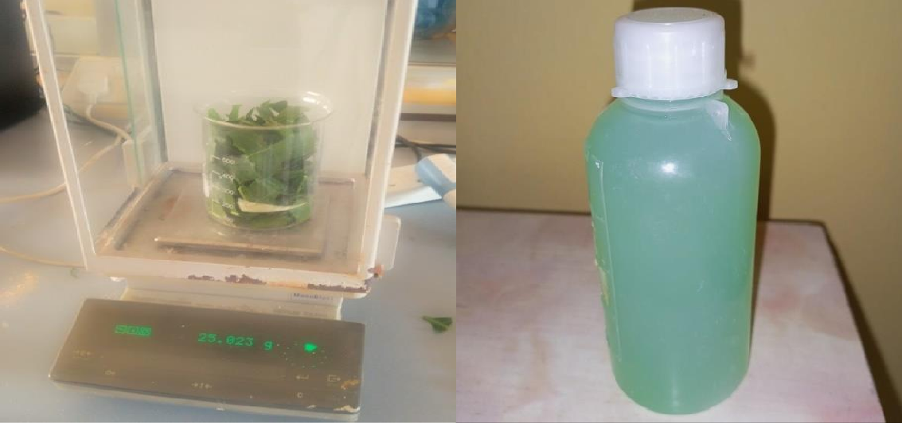
a
b
Plate X (a – b): (a). Mangifera Indica Leaf Phytochemical Screening (b). Mangifera indica Leaf Extracts
The result of the phytochemical screening of Mangifera Indica is presented in Table 4.14. The results indicated a reasonably high phenol, flavonoids and tannin contents with biologically active compounds that possess some disease-preventive properties and were, therefore, a suitable phytochemical screening agent to produce Ag/ZnO nanoparticles.
Table 4.14: Phytochemical Screening of Mangifera indica

Plant Part | Tannin (mg/g) | Flavonoid (mg/g) | Total Phenol (mg/g)
Mango Leaves | 0.90 | 0.0183 | 5.348
The phenol composition of the Mangifera indica was found to be 5.348 mg/g. Phenolic is the largest category of phytochemicals and is most widely distributed in Mangifera indica. Phenol is an antiseptic and disinfectant. It is active against a wide range of micro-organisms including some fungi and viruses, but slowly effective against spores. The mechanisms of action of phenolic compounds on bacterial cells have been partially attributed to the damage of the bacterial membrane, inhibition of virulence factors such as enzymes and toxins, and suppression of bacterial biofilm formation. Some natural
polyphenols, aside from direct antibacterial activity, exert a synergistic effect when combined with common chemotherapeutics (Miklasińska et al., 2018).
The flavonoid composition of the Mangifera indica was 0.0183 mg/g. Flavonoids possess many useful properties such as anti-inflammatory activity, oestrogenic activity, enzyme inhibition, antimicrobial activity, antiallergic activity, antioxidant activity, vascular activity and cytotoxic antitumour activity (Cushnie and Lamb, 2005).
The antimicrobial properties of Mangifera indica are attributed to its high flavonoid content. The flavonoid mode of antibacterial activity is due to cell lysis and disruption of the cytoplasmic membrane upon membrane permeability. Flavonoids show antimicrobial effects by inhibiting virulence factors, biofilm formation, membrane disruption, cell envelop synthesis, nucleic acid synthesis, and bacterial motility inhibition.
The tannin composition of the Mangifera indica was 0.90 mg/g. The antibacterial effectiveness of tannins is explained by their ability to pass through the bacterial cell wall up to the internal membrane, interfering with the metabolism of the cell that results in their destruction. In gram-positive bacteria, the activity of tannins is rapid. Tannic acid inhibits the bacteria attachment to the surfaces and a lack of bacteria adhesion to the surface results in bacteria cell death. Moreover, the sugar and amino acid uptake are inhibited by tannic acid and therefore limits the bacteria growth (Kaczmarek, 2020).

    - Syntheses of silver oxide and zinc oxide nanoparticles

The synthesised Ag and ZnO nanoparticles are shown in Plate XI (a - b). The synthesised Ag and ZnO nanoparticles oven-dried at 105 °C for 6 hours, calcined in the furnace at 450 °C for 3 hours were kept in a plastic bottle for further characterisation.
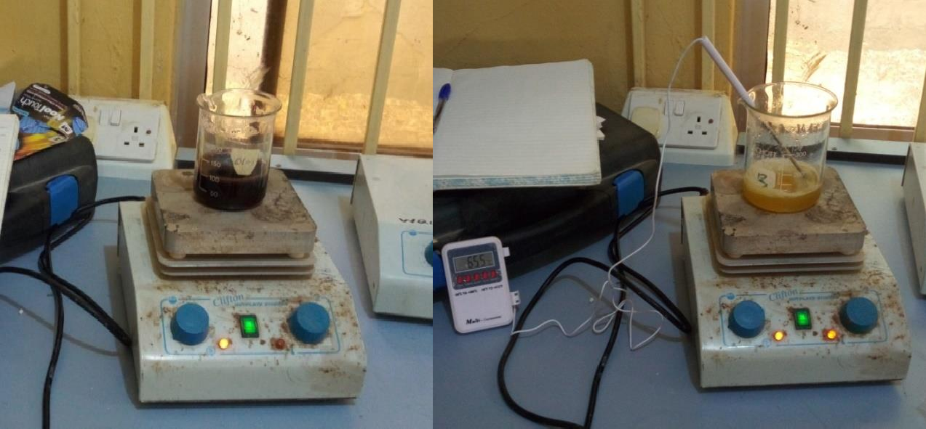
b
a
Plate XI (a – b): (a) Green Syntheses of Silver Oxide Nanoparticles, (b). Zinc Oxide Nanoparticles
    - XRD analysis of Ag nanoparticles

An XRD profile of Ag nanoparticles was found to contain one distinctive phase of silver

– 3C with formula Syn-Ag between 15.000° and 80.019°. XRD pattern for Ag nanoparticles showed four distinct diffraction peaks at 38.117°, 44.278°, 64.427° and 77.475° and indexed the planes at 1 1 1, 2 0 0, 2 2 0 and 311 of the face-centred cubic silver respectively. The data obtained was matched with the database of the Joint Committee on Powder Diffraction Standards (JCPDS) File No. 00-004-0783.

The average interplanar spacing of Ag nanoparticles was calculated to be 1.7748 nm. The average crystallite size of the Ag nanoparticles was calculated to be 30.6285 nm at Scherrer’s constant of 0.94 and wavelength (λ) of 1.5406 Å as presented in Table 4.15.

Table 4.15: Interplanar Spacing and Crystallite Size of Ag Nanoparticles

Diffraction Angle, 2θ | d- spacing, (nm) | FWHM of the Intense Peak, β, (radians) | Crystallite Size, D, (nm)
38.117 | 2.3660 | 0.2176 | 40.344
44.278 | 2.0500 | 0.2875 | 31.158
64.427 | 1.4490 | 0.3581 | 27.385
77.475 | 1.2342 | 0.4502 | 23.626
Average | 1.7748 |  | 30.6285
The XRD pattern showing various peaks produced in the characterisation of Ag nanoparticles is presented in Figure 4.3 (A).
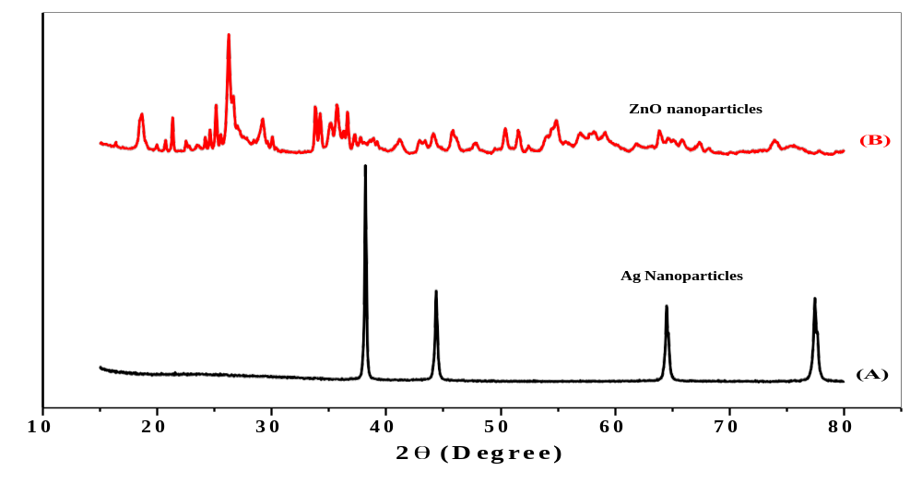
Figure 4.3: XRD patterns of (A) Ag and (B) ZnO Nanoparticle

Conclusion
The synthesis and characterization of silver nanoparticles (AgNPs) and zinc nanoparticles, particularly zinc oxide nanoparticles (ZnONPs), using Mangifera indica (mango) leaf extracts represent a promising, environmentally friendly approach to nanomaterial production. This method combines the principles of green chemistry with nanotechnology by utilizing naturally occurring phytochemicals in mango leaves as reducing, stabilizing, and capping agents. These phytochemicals may include flavonoids, tannins, terpenoids, and other bioactive compounds that facilitate nanoparticle formation and help regulate their physicochemical properties. The use of Mangifera indica leaf extract offers several advantages over conventional chemical and physical synthesis methods, including reduced reliance on hazardous chemicals, simplicity of preparation, and the use of a readily available plant resource. Consequently, green synthesis provides an alternative approach for producing nanomaterials with potential applications in medicine, environmental remediation, agriculture, and industrial processes.
The synthesis of silver nanoparticles involves the reduction of silver ions (Ag⁺) to metallic silver (Ag⁰), with plant-derived phytochemicals contributing to the reduction and stabilization processes. The formation of silver nanoparticles can be initially monitored through visible colour changes in the reaction mixture and subsequently confirmed using suitable analytical techniques. The role of the mango leaf extract in this process is not necessarily identical to its role in silver nanoparticle synthesis. Rather than assuming that zinc ions undergo direct reduction to metallic zinc, it is more scientifically appropriate to recognize that plant-derived compounds may facilitate complexation, stabilization and the formation of zinc-containing nanostructures. X-ray diffraction (XRD) can be used to identify the crystalline phase of the resulting material.The green synthesis of silver and zinc oxide nanoparticles using Mangifera indica leaf extracts has considerable scientific and technological potential. When supported by reliable experimental evidence, this approach may contribute to the development of environmentally responsible nanomaterials.
Recommendation
The preparation of mango leaf extract should be standardized to improve consistency between experimental batches. Researchers should document the source and maturity of the leaves, washing procedures, drying conditions, extraction solvent, extraction temperature, extraction duration, and extract concentration.
Where feasible, phytochemical screening and quantitative analysis of selected compounds should be conducted to determine which constituents may contribute to nanoparticle formation and stabilization. This will help establish a clearer relationship between the chemical composition of the extract and the properties of the synthesized nanoparticles.
Further research should compare the properties of AgNPs and ZnO NPs prepared under carefully controlled conditions using the same source of mango leaf extract. Such comparisons should consider particle size, morphology, crystallinity, surface chemistry, stability, synthesis yield, and functional performance.Appropriate controls should include the plant extract alone, precursor solutions without the extract, and suitable reference materials. These controls will help distinguish effects caused by the plant extract from those associated with the nanoparticles themselves.

References

America Public Health Association (APHA) (2017). Standard methods for Examination of Water and Wastewater. APHA, AWWA, WEF. 23rd Edition, Published by E and FN SPON, Washington D.C.
Chandrakala, V.; Aruna, V.; Angajala, G. Review on metal nanoparticles as nanocarriers: Current challenges and perspectives in drug delivery systems. Emergent Mater. 2022, 5, 1593–1615.
Cushnie, T. P. T., & Lamb, A. J. (2005). Antimicrobial activity of flavonoids. International Journal of Antimicrobial Agents, 26(5), 343–356, doi:10.1016/j.ijantimicag.2005.09.002.
Filippov, A.; Bonjoc, K.-J.C.; Chea, J.; Bowles, N.; Poku, E.; Chaudhry, A. Role of Theranostics in Thoracic Oncology. J. Thorac. Dis. 2020, 12, 5140–5146..

Gomes Marin, J.F.; Nunes, R.F.; Coutinho, A.M.; Zaniboni, E.C.; Costa, L.B.; Barbosa, F.G.; Queiroz, M.A.; Cerri, G.G.; Buchpiguel, C.A. Theranostics in Nuclear Medicine: Emerging and Re-Emerging Integrated Imaging and Therapies in the Era of Precision
Oncology. Radiographics 2020, 40, 1715–1740.

Hebeish,A ,A., EI-Rafie ,M H.,EI-Sheikh, M., A ,.& Seleem, A.A (2010). Carboxymethyl celluiose for green synthesis and stabilization of silver nanoparticles.carbohydrate of silver nanoparticles,Carbohydrate polymers 82(2),933-941.

Hasna, A.S.; Rajeshwari, S.; Venckatesh, R. Green synthesis and characterization of zinc oxide nanoparticles from Ocimum basilicum L. var. purpurascens Benth.-Lamiaceae leaf extract. Mater. Lett. 2014, 131, 16–18

Ishwarya, R.; Vaseeharan, B.; Anuradha, R.; Rekha, R.; Govindarajan, M.; Alharbi, N.S.; Kadaikunnan, S.; Khaled, J.M.; Benelli,G. Eco-friendly fabrication of Ag nanostructures using the seed extract of Pedalium murex, an ancient Indian medicinal plant:
Histopathological effects on the Zika virus vector Aedes aegypti and inhibition of biofilm-forming pathogenic bacteria. J. Photochem. Photobiol. B Biol. 2017, 174, 133–143.

Kaczmarek, B. (2020). Tannic Acid with Antiviral and Antibacterial Activity as A Promising Component of Biomaterials: A Minireview. Materials, 3224, 13(14), 1-13, doi:10.3390/ ma13143224.

Miklasińska, M.M., Kępa, M., Wojtyczka, R., Idzik, D., & Wąsik, T. (2018). Phenolic compounds diminish antibiotic resistance of staphylococcus aureus clinical strains. International Journal of Environmental Research and Public Health, 15(10), 1-18, doi:10.3390/ ijerph15102321
Njagi, E. C., Hui, H., Lisa, S., Homer, G., Hugo, M. G., John, B. C., George, E. H., & Steven, L. S. (2010). Biosynthesis of Iron and Silver Nanoparticles at Room Temperature Using Aqueous Sorghum Bran Extracts. Langmuir article, 27(1), 264–271, doi: 10.1021 /la103190n Langmuir 2011

Naidu, E.C.S.; Olojede, S.O.; Lawal, S.K.; Rennie, C.O.; Azu, O.O. Nanoparticle delivery system, highly active antiretroviral therapy, and testicular morphology: The role of stereology. Pharmacol. Res. Perspect. 2021, 9, e00776.

Dikshit, P.K.; Kumar, J.; Das, A.K.; Sadhu, S.; Sharma, S.; Singh, S.; Gupta, P.K.; Kim, B.S. Green synthesis of metallic nanoparticles:Applications and limitations. Catalysts 2021, 11, 902.

Miklasińska, M.M., Kępa, M., Wojtyczka, R., Idzik, D., & Wąsik, T. (2018). Phenolic compounds diminish antibiotic resistance of staphylococcus aureus clinical strains. International Journal of Environmental Research and Public Health, 15(10), 1-18, doi:10.3390/ ijerph15102321

Ishwarya, R.; Vaseeharan, B.; Anuradha, R.; Rekha, R.; Govindarajan, M.; Alharbi, N.S.; Kadaikunnan, S.; Khaled, J.M.; Benelli,G. Eco-friendly fabrication of Ag nanostructures using the seed extract of Pedalium murex, an ancient Indian medicinal plant:
Histopathological effects on the Zika virus vector Aedes aegypti and inhibition of biofilm-forming pathogenic bacteria. J. Photochem. Photobiol. B Biol. 2017, 174, 133–143.

Sushma, N.J.; Mahitha, B.; Mallikarjuna, K.; Raju, B.D.P. Bio-inspired ZnO nanoparticles from Ocimum tenuiflorum and theirin vitro antioxidant activity. Appl. Phys. A 2016, 122, 544.
Sierra, M. J., Adriana, Herrera, P., & Karina, A. O. (2018). Synthesis of zinc oxide nanoparticles from mango and soursop leaf extracts. Contemporary Engineering Sciences, 11(8), 395 – 403, https://doi.org/10.12988/ces.2018.8228
Shimadzu (2008). Instruction Manual Operation Guide for Ultraviolet 1800 Shimadzu spectrophotometer. Analytical and Measuring Instruments Division, Shimadzu Corporation, Kyoto Japan

Ovais, M.; Khalil, A.T.; Islam, N.U.; Ahmad, I.; Ayaz, M.; Saravanan, M.; Shinwari, Z.K.; Mukherjee, S. Role of plant phytochemicals and microbial enzymes in biosynthesis of metallic nanoparticles. Appl. Microbiol. Biotechnol. 2018, 102, 6799–6814

